**CAPSTONE PROJECT – ICIN BANKING PORTAL**

**Project and developer details**

The Project is developed by Rishabh Dixit

The all code of project is hosted on GitHub: <https://github.com/dixitrishabh/Capstone-Project>

**Sprints planned and the tasks achieved in them**

Creating a document and file structure of the project.

Then I generate a spring boot application and import in eclipse by clicking on maven and existing maven project and project is imported all jars files will be imported in the project.

I work on project and build a user portal in this part.

Then for admin portal I used angular for building

npm install - g @angular/cli

ng new AdminPortal

cd AdminPortal

ng serve -open

**Tools and technologies used:**

• Database management: MySQL

• Back-end: Java, SpringBoot

• Front-End: HTML/CSS, Angular

• DevOps and Production: Git, GitHub, AWS, and Jenkins

Project File structure

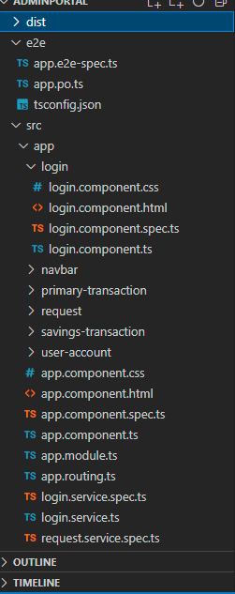 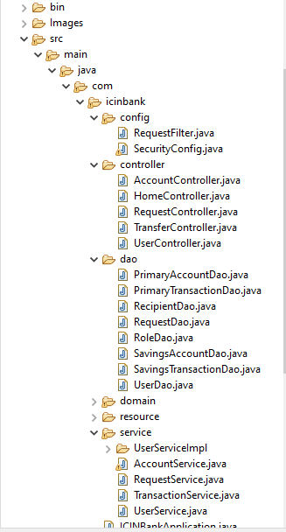

Sign Up page:

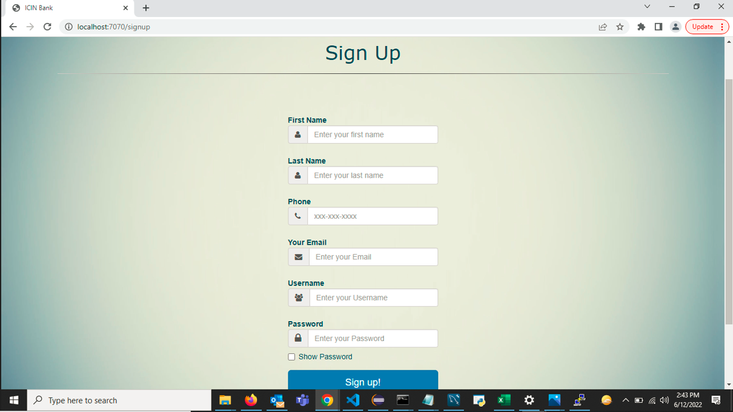

Sign In Page

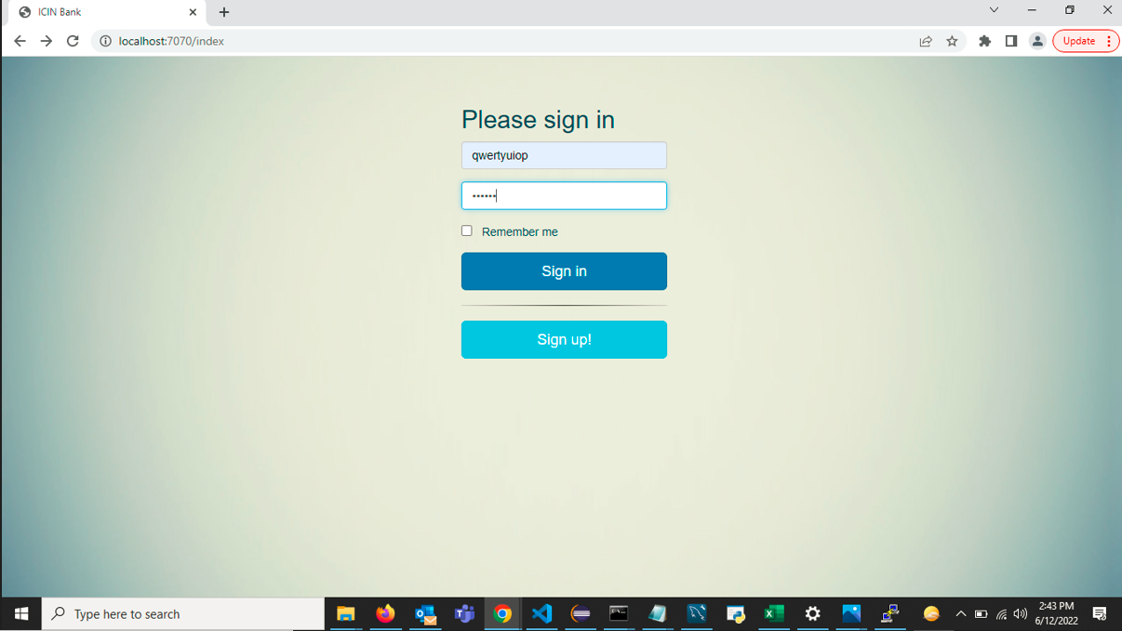

Home Page

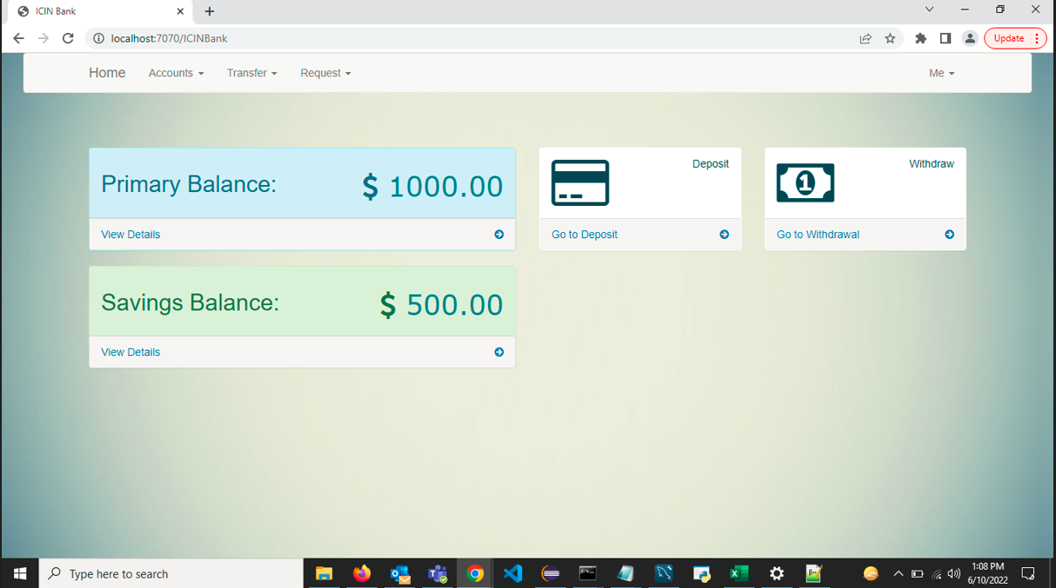

Primary Account Balance

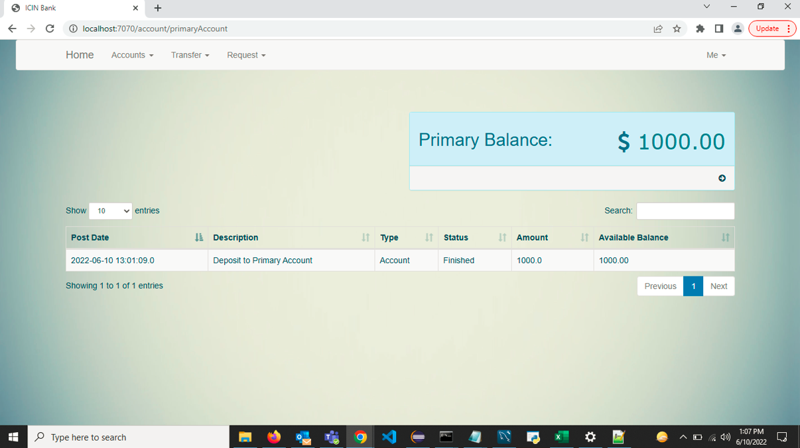

Transfers

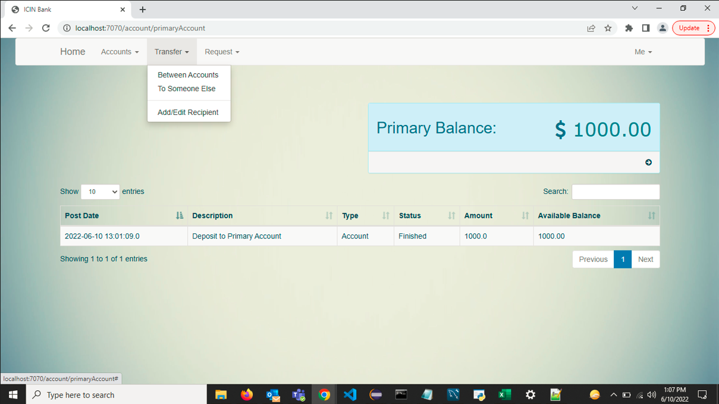

Request

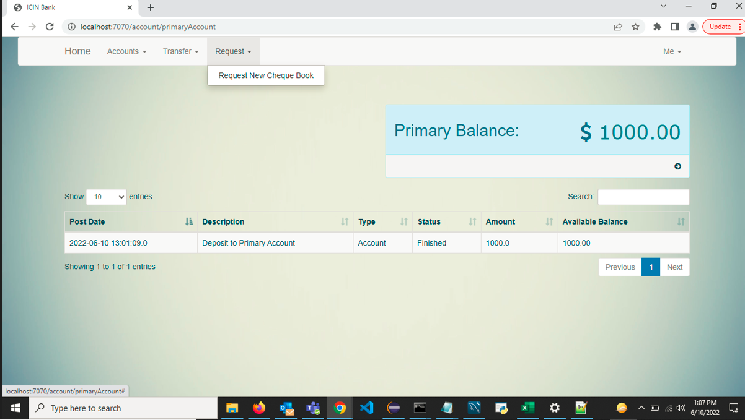

User Profile

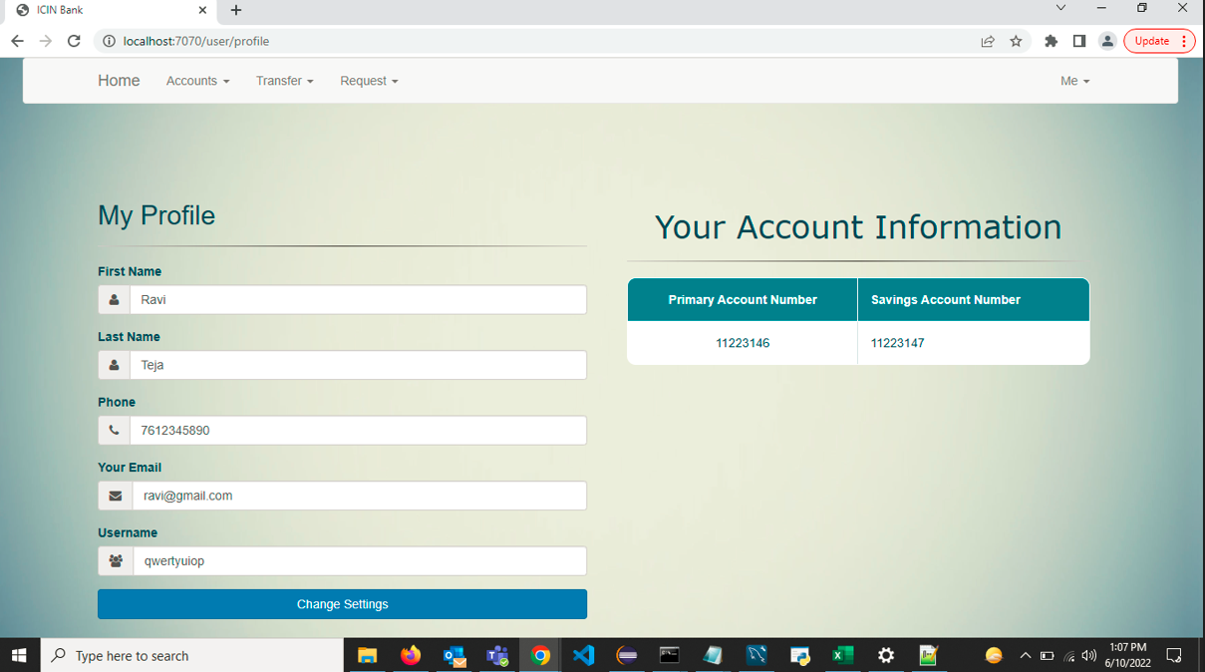

Recipient Information Page

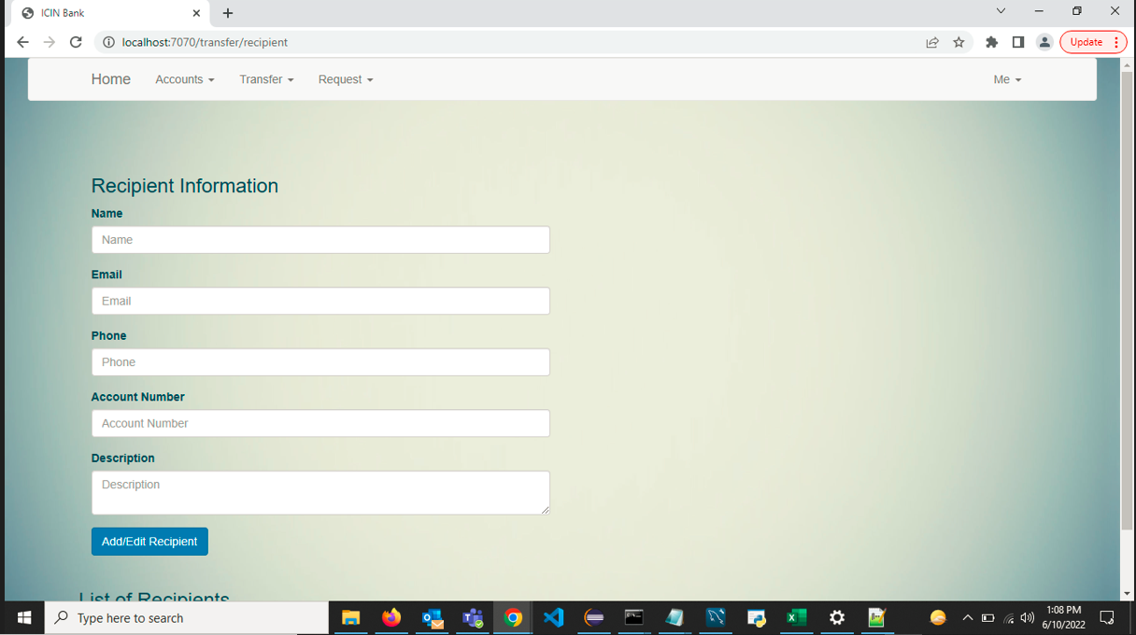

Deposit

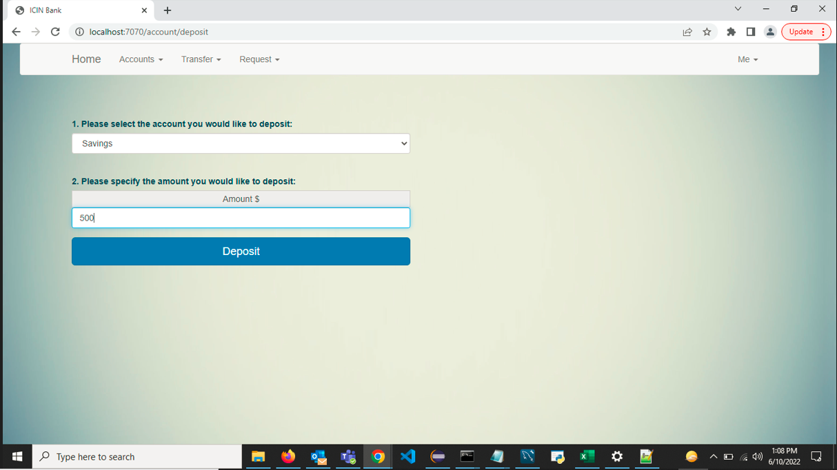

Withdraw

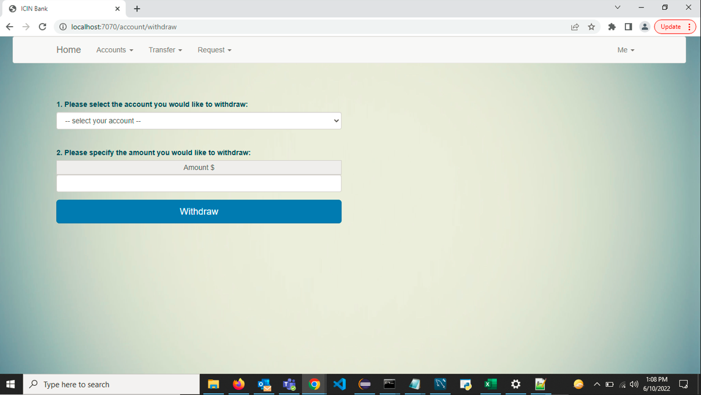

Log out

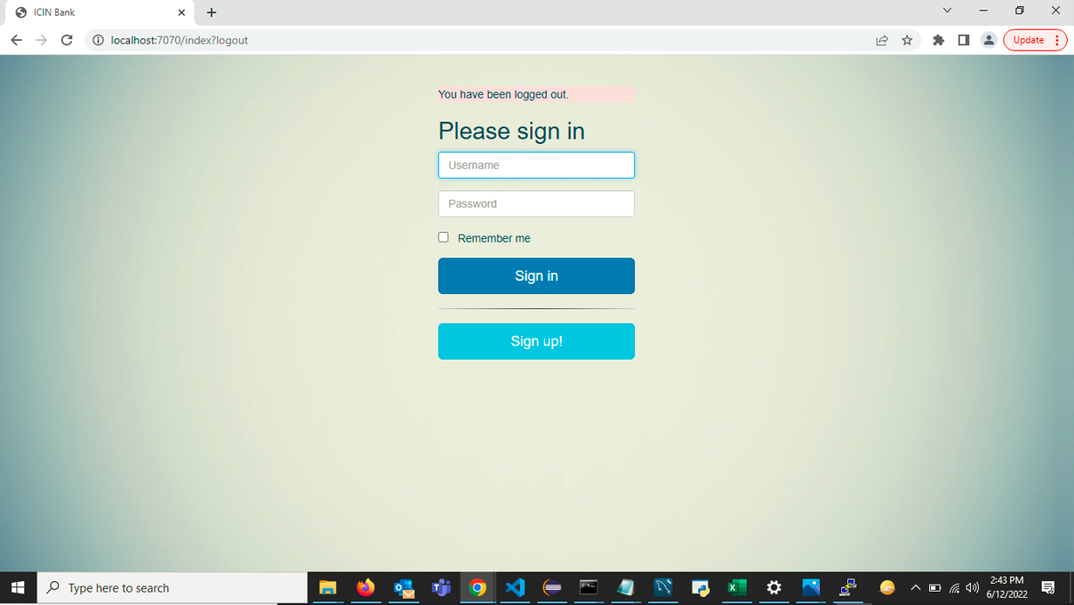

Admin Portal

Admin Log In

User Account Details

Connection with Putty:

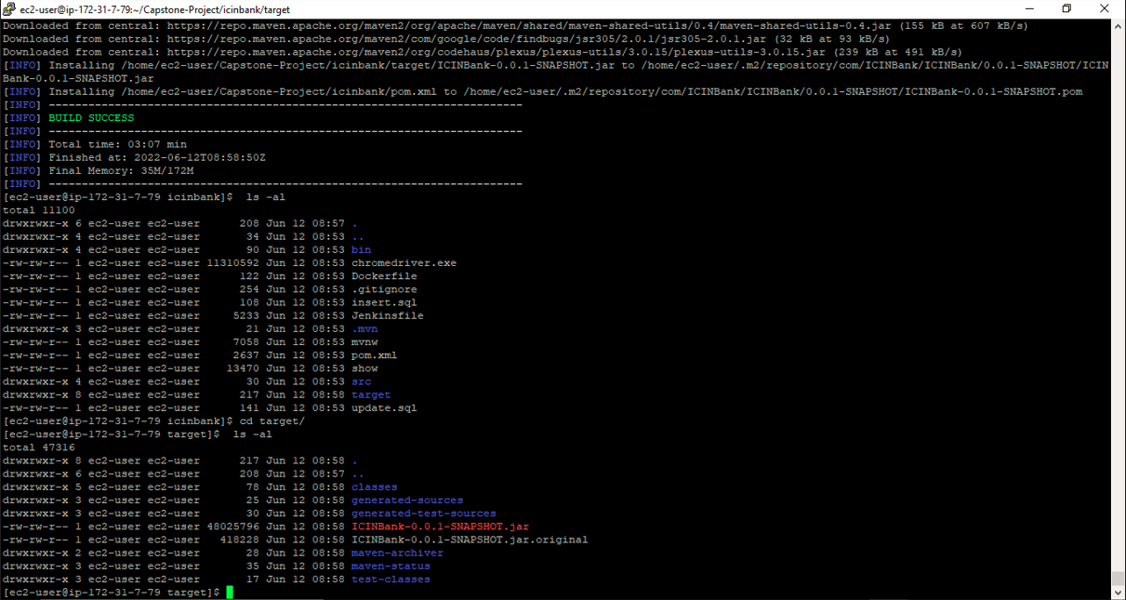

Running the application with help of public IP

Jenkins Part

GitHub Link - <https://github.com/dixitrishabh/Capstone-Project>

**Your conclusion on enhancing the application and defining the USPs (Unique Selling Points):**

Project features:

* Responsive and dynamic application with Admin and User Portal
* The user can:
  + Register a new account or log in to the existing account.
  + Deposit and withdraw money from the account.
  + View transactions and balance of the accounts.
  + Transfer fund between the accounts.